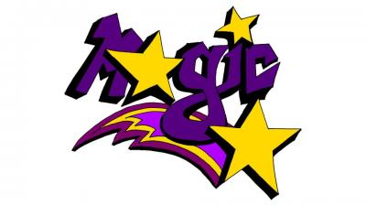JOHN MARTIN JUNIOR HIGH SCHOOL NORMS
School Norms | What Does This Look Like for Students?
We will be respectful to ourselves, others, and our environment. | - No discriminatory /racist/derogatory language  - Speaking respectfully to peers and adults  - Tone  - Volume  - Situational awareness  - SCHOOL APPROPRIATE LANGUAGE  - No physical contact between peers (hands feet objects)  - No excluding others  - No name calling  - Using preferred pronouns/names  - Taking care of our belongings (pencils, Chromebooks, desks)  - Respect space, desks, hallway- no vandalizing/graffiti (Ms. Fudge works hard)
Technology will be used for learning with teacher permission. | - Can use phone during scheduled tech break- last 10 minutes of block 2  - Cell phones away during instruction.  - Phones away (out of sight, out of mind) UNLESS directed by the teacher  - Students MUST ask before checking personal technology- calls/texts from family.  - Recording others, taking pictures of others, and/or playing music aloud in the hallway is not permitted
We will follow our schedule and go directly to our scheduled classes. | - Go directly to the next class.  - No bathroom/drink during class change.  - Be on time when school starts.
We will work well with others. | - Listen when others are talking.  - Be accepting of your seat/group (have a private conversation with your teacher if unhappy).  - Do your best to contribute.  - Respect others' personal space.
We will be accountable and accept responsibility for our actions. | - We will keep our hands, feet, and objects to ourselves.  - We will participate in learning activities.  - We will admit when we’ve made a mistake.  - Put effort into making small changes in behavior.  - Take immediate measures to make amends.  - Being open to follow up conversations.
JOHN MARTIN JUNIOR HIGH SCHOOL NORMS

- We will be respectful to ourselves, others, and our environment.

- We will use technology for learning with teacher permission.

- We will follow our schedule and go directly to our scheduled classes.

- We will work well with others.

- We will be accountable and accept responsibility for our actions.

