**John Martin Junior High School Supply List 2025-2026**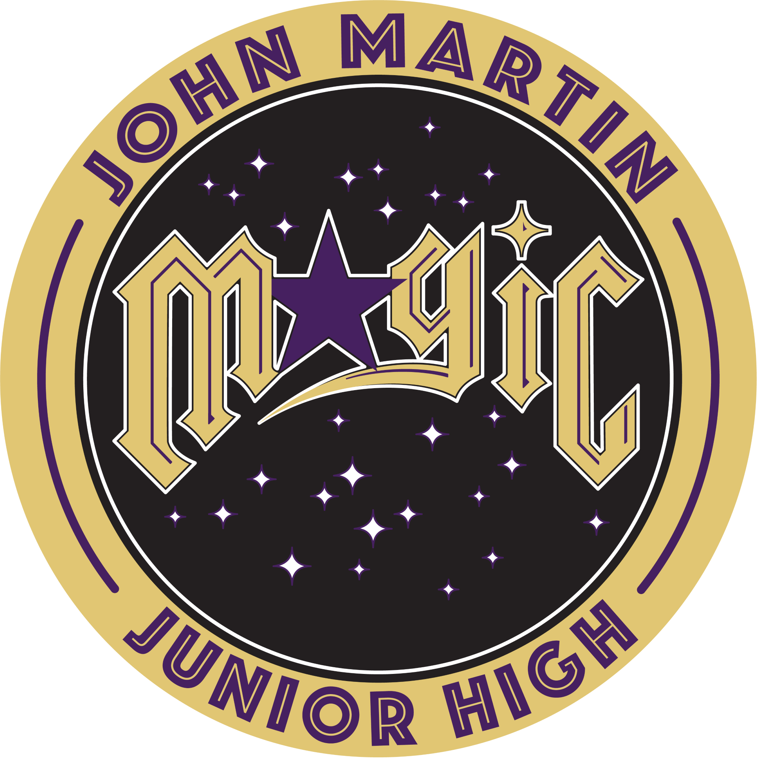

| * Students are not provided a locker, as we do not currently have enough lockers for our student population. * All student supplies should be kept in student bookbags for grades 7/8/9. * Grade 6 supplies are *kept in their classrooms.* |
| --- |

**ART 7/8/9**

| Scissors | Markers | 1 Sketchbook (dollar store) | Colored Pencils (pack of 24) |
| --- | --- | --- | --- |
| Pencils | Erasers | Black fine line marker(s) | glue stick |

**MATH 7/8/9**

| 1 Three Ring Binder | Pencil case that clips in the binder | 50 pages of graph paper | Sharpener |
| --- | --- | --- | --- |
| 1 Scribbler  (with the holes punched in the side) | Colored pencils (12 pack) | 400 pages of loose leaf | Erasers |
| 1 Basic Calculator (dollar store) (Scientific calculator for grade 9) | Pencils | 1 Sharpener | Water Bottle (to be used in all classes) |

**ENGLISH LANGUAGE ARTS 7/8/9**

| Pencils | 1 pack of Loose-Leaf | Earbuds/Headphones |
| --- | --- | --- |
| Journal/Composition Book for Writing | 1 Duotang or Binder | Erasers |

.

**Grade 6**

| Pencils | 1 pack of Loose-Leaf | Earbuds/Headphones |
| --- | --- | --- |
| Protractor | 6 Pocket Folders | Erasers |
| Scissors | Markers & or Coloured Pencils  (any size) | 1 Sharpener |
| 1 Basic Calculator | Water Bottle (to be used in all classes) | Glue Stick(s) |
| Pencil Case |  | Ruler (12 inches) |
|  |  |  |